

**CST1500 Coursework Report**

**2020 September Intake**

**Python  
Simple Calculator**

**Yagessen Ramanjooloo**

**M00796787**

**Justin Mayer**

**M00796450**

Table of Contents

Introduction 2

Development 3

Approach 3

Encountered problems 4

Conclusion 6

References 7

# Introduction

For this coursework, the aim was to create a Simple Calculator in python, with various functionalities such as Multiply, Divide, Add or Subtract. Immediately, the idea of creating ‘personalized features’ according to the Computer Science field comes to mind. That is why the calculator embark a ‘Programmer Mode’ letting the user Convert a decimal to the numeral system of its choice (Octal, Hexadecimal or Binary). Moreover, the calculator contains features such as Clear / Backspace for complexity of operations. The GUI used for this coursework is made, of course with Tkinter, as taught in class and were Inspired By the Windows 10 Calculator, simple, clean and modern aspects (Figure 1)

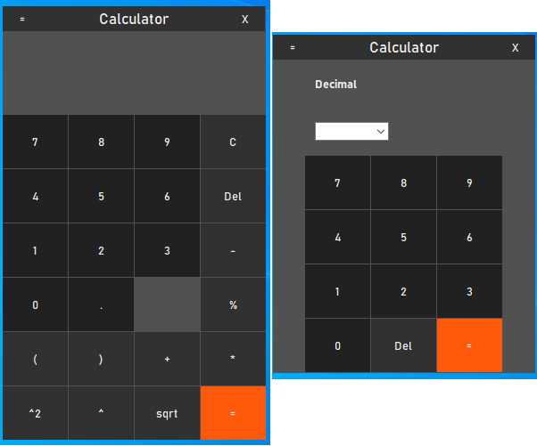

Figure 1

# Development

## Approach

The First approached was to create a Calculator using frames grouping same objects, buttons, labels, etc.… The GUI (Tkinter, figure 2.1) (anzeljg.github.io,n.d.) was firstly made and the functions for a working Calculator were made after.  
The buttons would work using the same function, with a different argument, printing on the textvariable label, a character different from each button.



Figure 2

The Calculator Contain different functional parts:

From the Basic Mode: Figure 3

* Result Label / Button Pad / Historic / Menu Button

Figure 3

From the Menu Mode: figure 3

* Buttons

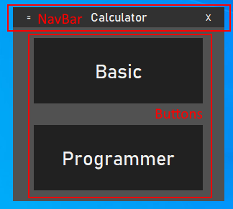

Figure 4

From the Programmer Mode: figure 4

* Entry / Selector + Conversion / Pad

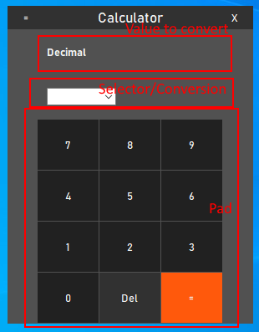

Figure 5

As seen The Top Navigation Bar is the same for all Modes.

## Encountered problems

* Main problem encountered during the development of the calculator was the method of selecting a function for a button.  
  Effectively, A Tkinter Button function with a ‘command=’option, taking a function without

passing arguments. To pass arguments as wanted, for using the same command and printing different character for each button, we had to use Lambda function (figure 7).A lambda function is a small function that is anonymous and always return a single expression

(Stack Overflow, n.d.).

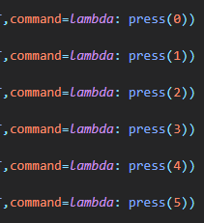

Figure 6

* Moreover, the Hovering system from the button needed researches and Lambda functions (figure 9). Usage of “Enter>” and “Leave>” (Pythonprogramming.net, 2019) from Tkinter to recognize when the mouse is pointing to the buttons (figure 8).

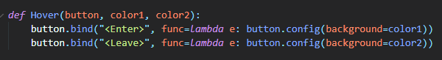

Figure 7

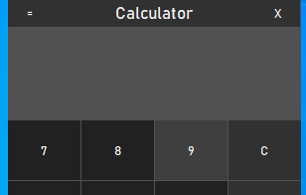

Figure 8

# Conclusion

To conclude, knowledge and research acquired during tuition and online were the keys to create this program. The calculator itself looks satisfying, as it embarks 5 more mathematical operations than a basic one. But could also be upgraded, for example, like a two-way conversion for the programmer mode, where the user chooses the numeral system he wants to convert and to what numeral system it will convert.  
It was also design in a modernistic and user-friendly way to blend in the actual era. It was a delightful project putting hard work and reflexion, and this brought us even more knowledge.

# References

Stack Overflow. (n.d.). python - Tkinter Hovering over Button -> Color change. [online] Available at: <https://stackoverflow.com/questions/49888623/tkinter-hovering-over-button-color-change> .

Pythonprogramming.net. (2019). Python Programming Tutorials. [online] Available at: <https://pythonprogramming.net/passing-functions-parameters-tkinter-using-lambda/> .

anzeljg.github.io. (n.d.). Tkinter 8.5 reference: a GUI for Python. [online] Available at: <https://anzeljg.github.io/rin2/book2/2405/docs/tkinter/index.html> .‌